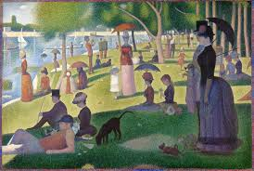
ART SMART FIELD TRIP SUGGESTIONS

Kindergarten. La Grange Art League, 122 Calendar Court

1st Grade La Grange Art League, 122 Calendar Court

2nd Grade. St. Francis Xavier Church Tour

3rd Grade. Nettie McKinnon Gallery @ Park Jr. High

4th Grade. Nettie McKinnon Gallery @ Park Jr. High

5th Grade. Nettie McKinnon Gallery @ Park Jr. Hi

6th Grade. NO FIELD TRIP

Contact and Scheduling Information:

La Grange Art League: Call the field trip coordinator at the Art League, 352-3101. The Art League has more flexibility in scheduling so you can wait until after the first of the year to secure a date. This is a walking field trip. www.lagrangeartleague.org

Nettie McKinnon Gallery: Please email JOYCE FITCH at joyceef@mindspring.com to schedule your visit. The gallery is located at Park Jr. High. This is a walking field trip. You should schedule your field trip as soon as possible, the gallery is very busy in May! Gallery website: www.saltcreekart.org

